Exercise 3

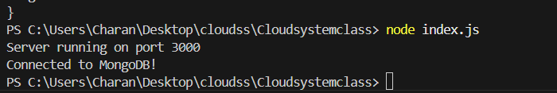

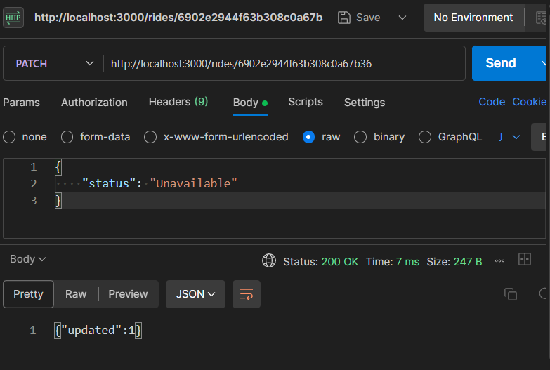
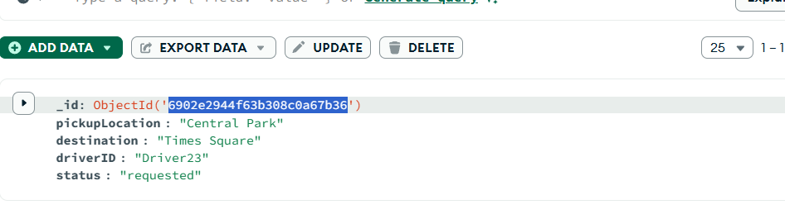

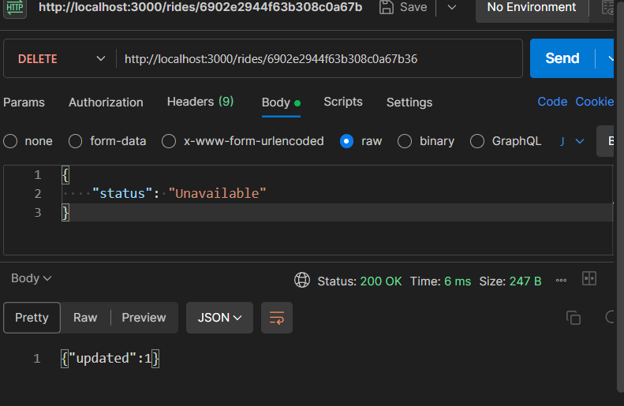
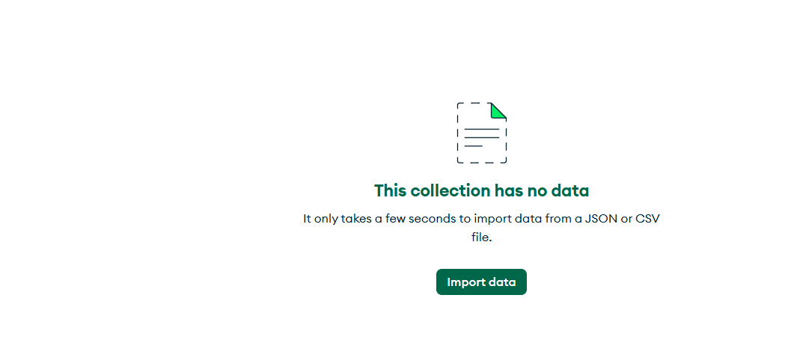

Lab Questions:
- What HTTP status code is returned when a ride is created successfully?
= 201 Inserted
- What is the structure of the response body?
= json({id: result.insertedId})
- What happens if the rides collection is empty?
= empty array ([])
- What data type is returned in the response (array/object)?
= array
- Catch the error when requesting PATCH or DELETE API, then try to fix the issue reported.
= error (400 bad request),
- If you try to update a non-existent ride ID, what status code is returned?
= Invalid ride ID or data
- What is the value of updated in the response if the update succeeds?
= updated “1”
- How does the API differentiate between a successful deletion and a failed one?
= If successful deletion {“deleted”:1} and “200 Ok”, If failed one {“ride not found”:1} and “404 not found” will be displayed.

- Based on the exercise above, create the endpoints to handle the CRUD operations for users account
=
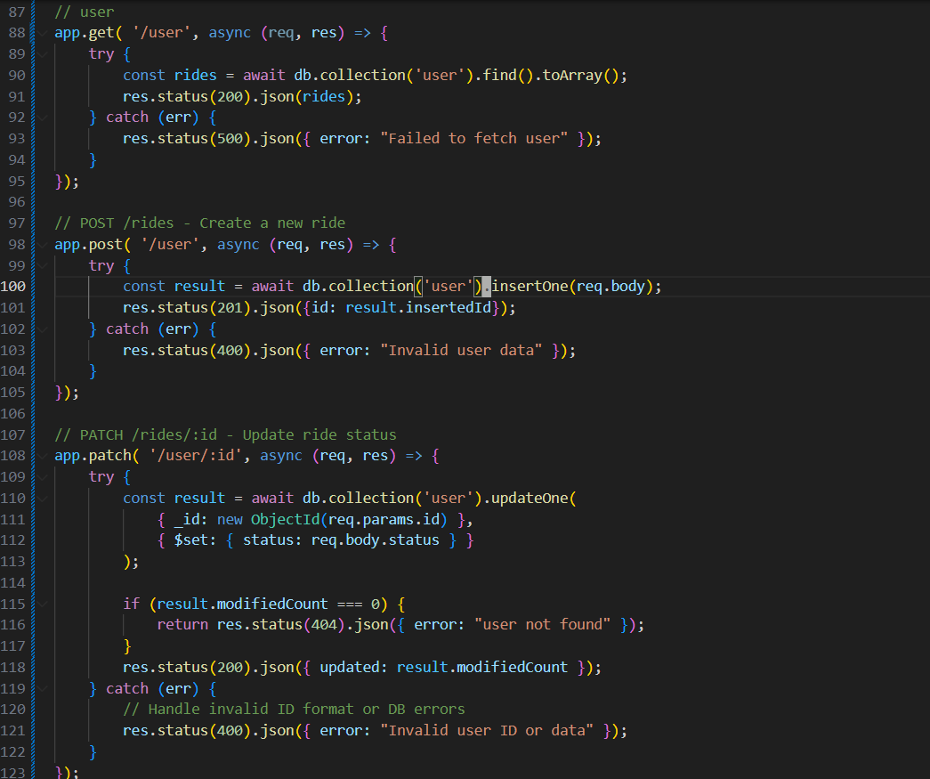
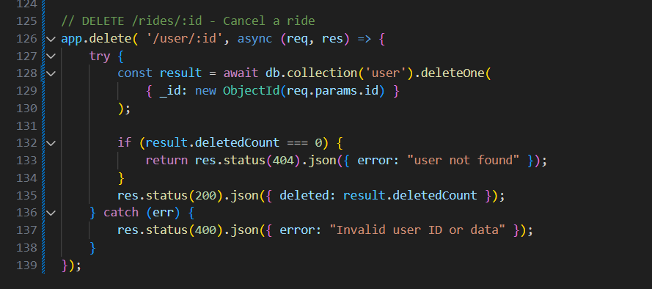

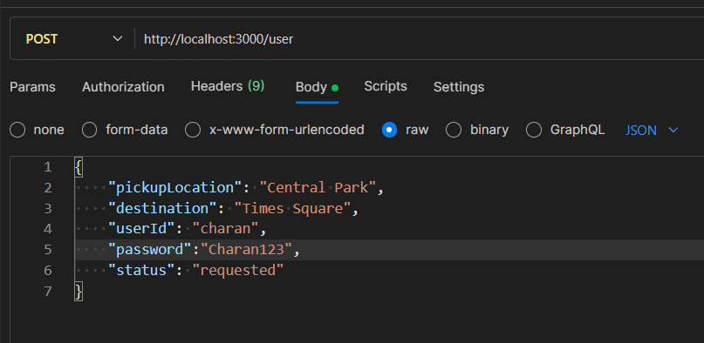

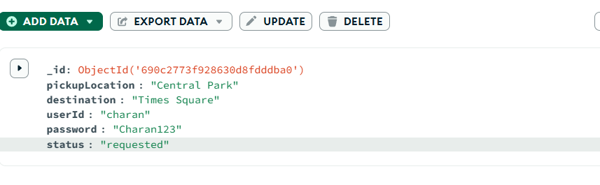

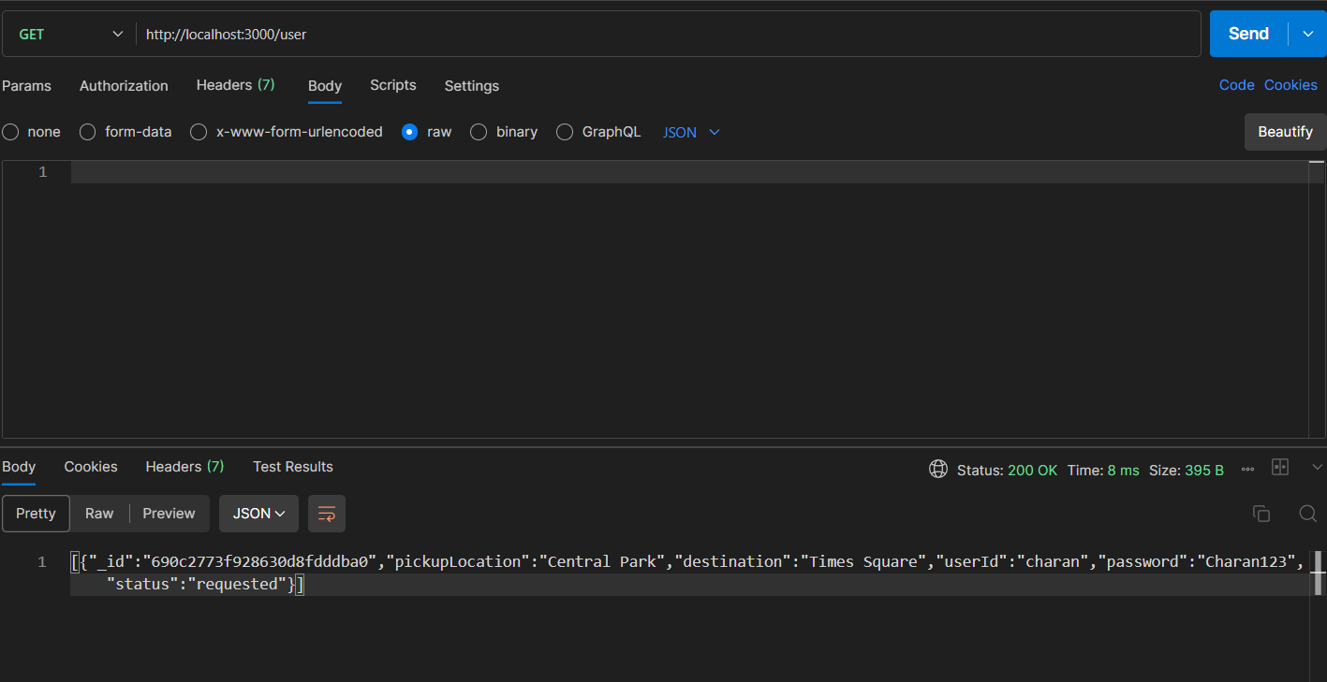

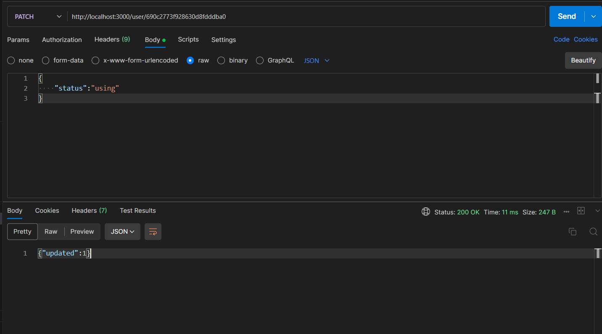
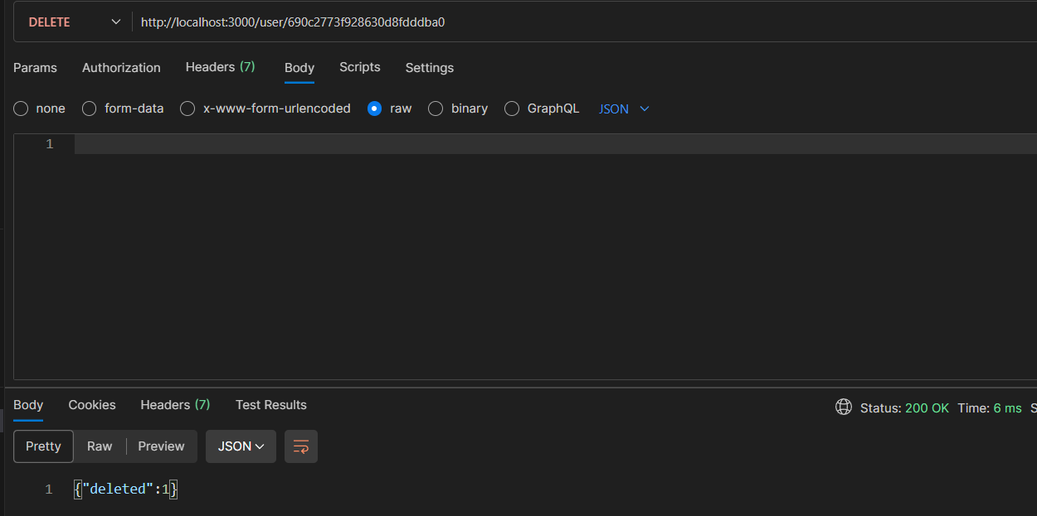

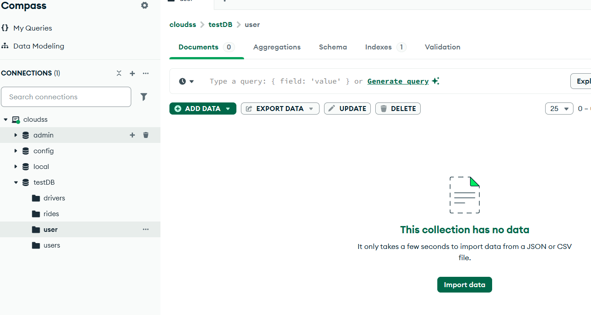

- Upload the Postman JSON to any AI tools, and generate a simple HTML and JS Dashboard for you

App.js
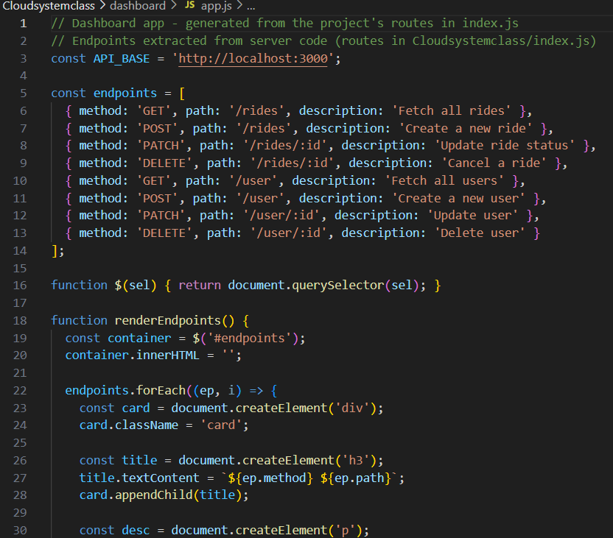
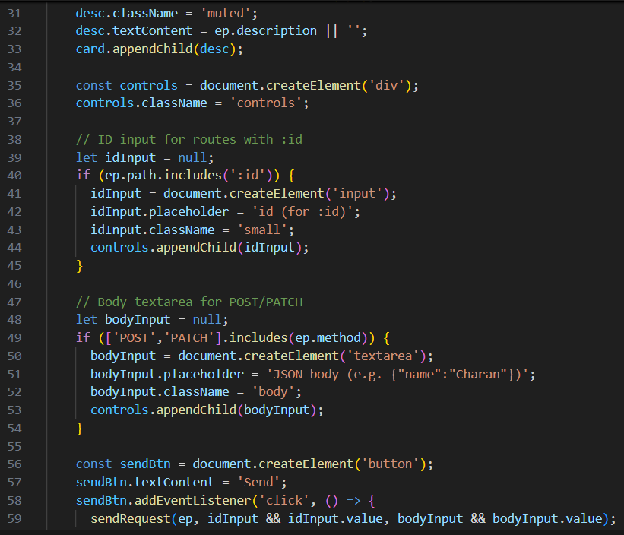

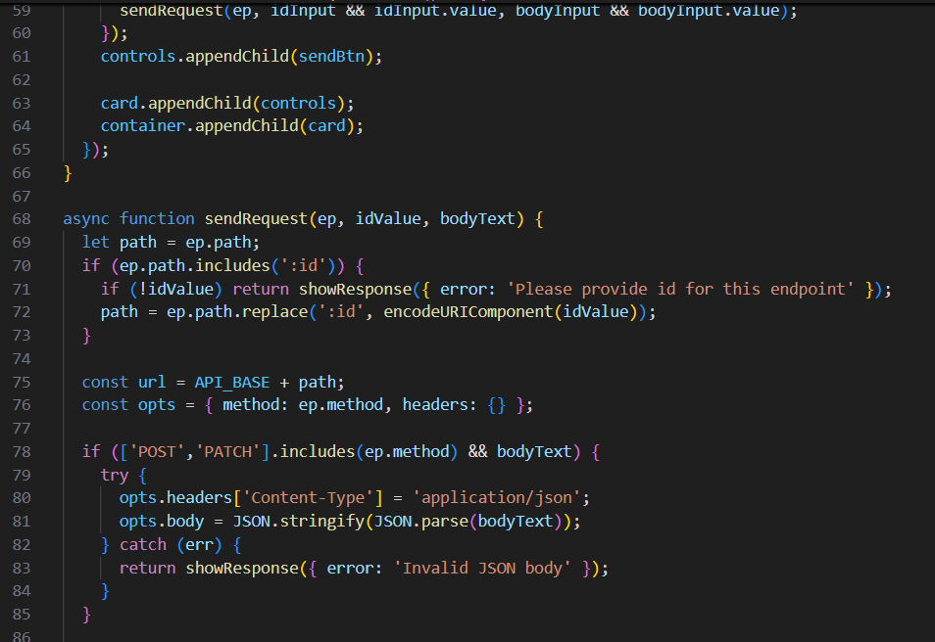
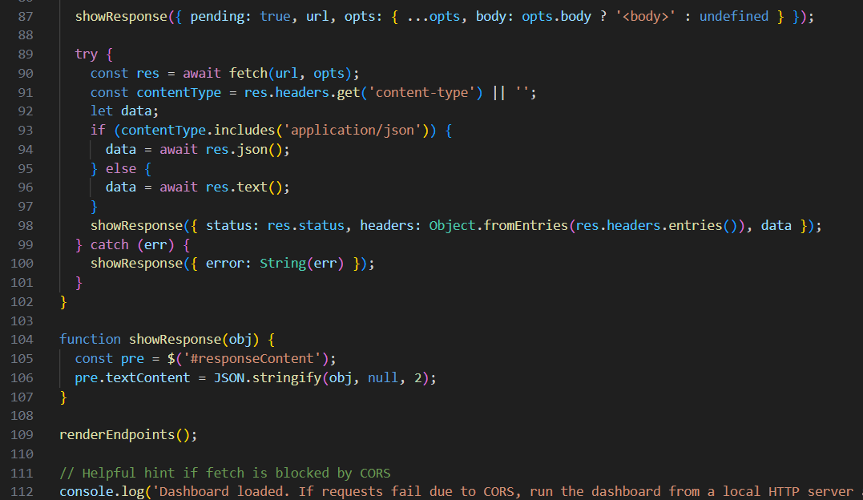

Index.html
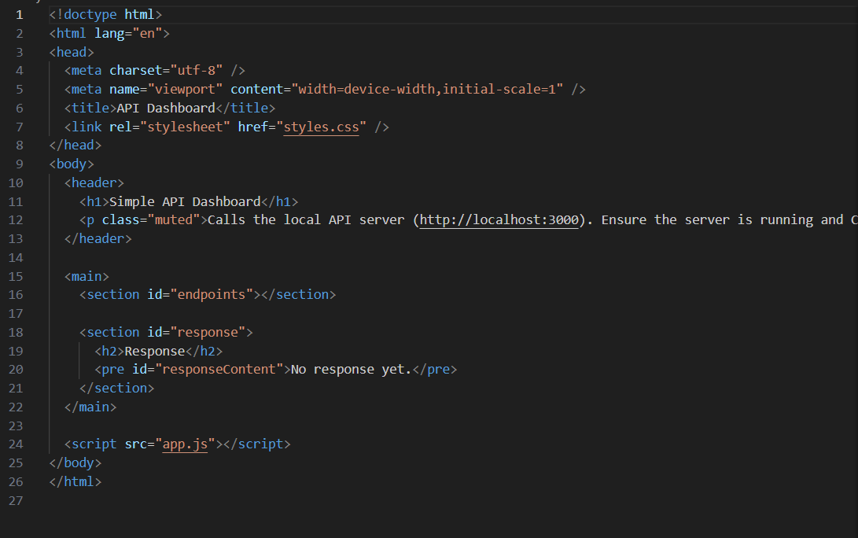

Styles.css
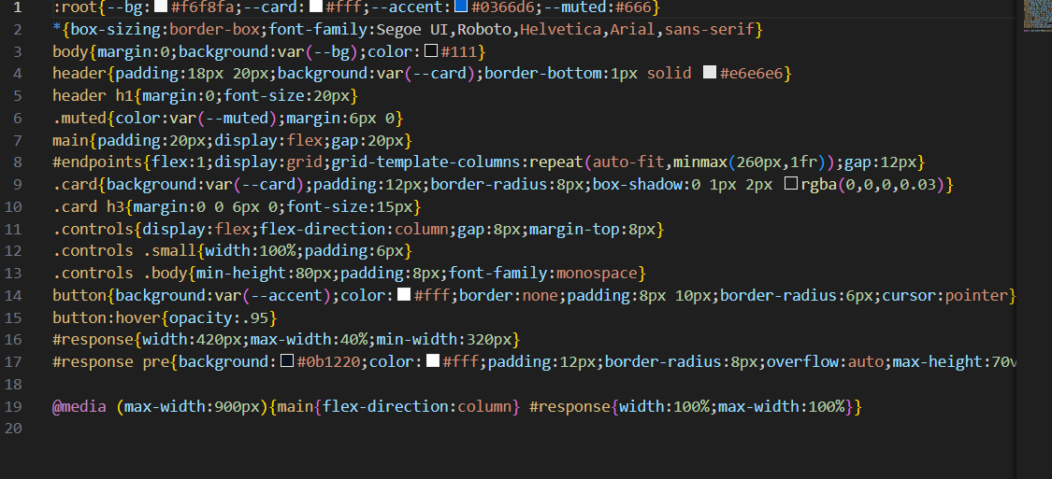

Result:

